**Part 2 Installing the Sensors and Autonomous Systems**

Before starting on the Autonomous modification it is important to check that the basic Rampaging Chariot chassis is working correctly. In particular check that:

* The battery is fully charged.
* The two Motor Drive Boards are delivering approximately the same power to the two drill motors.
* The full weight of the chassis is supported on the two drive wheels. (i.e. With one balancing wheel pushed into contact with the ground, there is a gap of approximately 5mm under the other balancing wheel.
* The two motor casings are firmly bolted to the MDF chassis and do not move or twist on the chassis when under power.
* All electrical crimps are firmly attached to their wires.

**2.1 Installing the Odometers In the Chassis**

The Odometers measure the rotation of the two drive wheels and thereby measure the distance travelled by each wheel. The difference between the distance travelled by each wheel is also used to calculate the heading angle of the chassis.

Each Odometer consists of a permanent magnet attached to the axle of the two drive wheels and a small PCB containing a sensor IC attached to the sides of the chassis in line with each magnet.

1. Remove the Batteries, Motor Drive Boards, Radio Receiver and Motors from the chassis.

1. Super-glue the 6mm diameter magnets into their special magnet housings (supplied). Drill pilot holes 1.5mm dia and fix onto each axle with three 2mm x 9mm brass countersink head screws. These special magnets are polarised diametrically (across the diameter) so they can be mounted either way up.

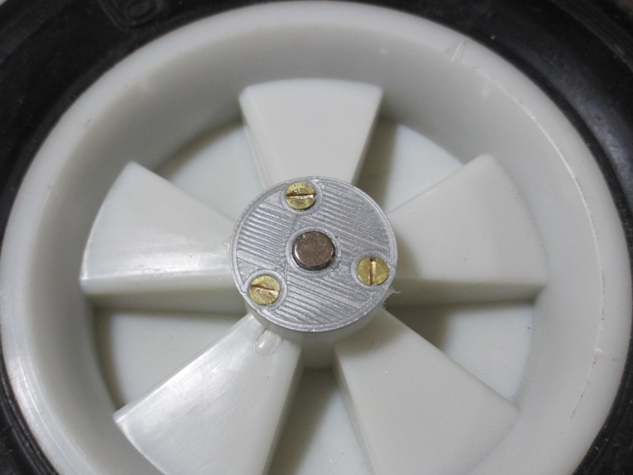

**Magnet Housing for Drive Axles**

1. Fit the two drive motors into the chassis and carefully mark the position of each magnet on the chassis sides with a vertical and a horizontal line.
2. Line up the centre of the sensor IC with the centre of the magnet on the axle. The wires should be towards the front of the chassis in each case. There should be a gap of 1mm between the magnet face and the top surface of the sensor IC. Depending on the existing gap, this may require a small fillet of wood or cardboard packing behind the Sensor PC board, or a hollow cut into the side panel MDF and the Sensor IC sunk into the surface.

**Hint**: You can use a small blob of BlueTac to finally level and adjust the height of the odometer PCB.

1. Attach the sensor PCB to the side of the chassis with two 2mm x 9mm brass countersink head screws. The accuracy of alignment is very important to the accuracy of the Odometer, so aim to get the magnet on the axle lined up within 1mm.

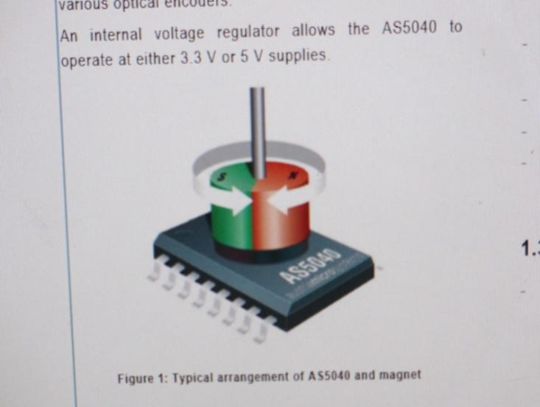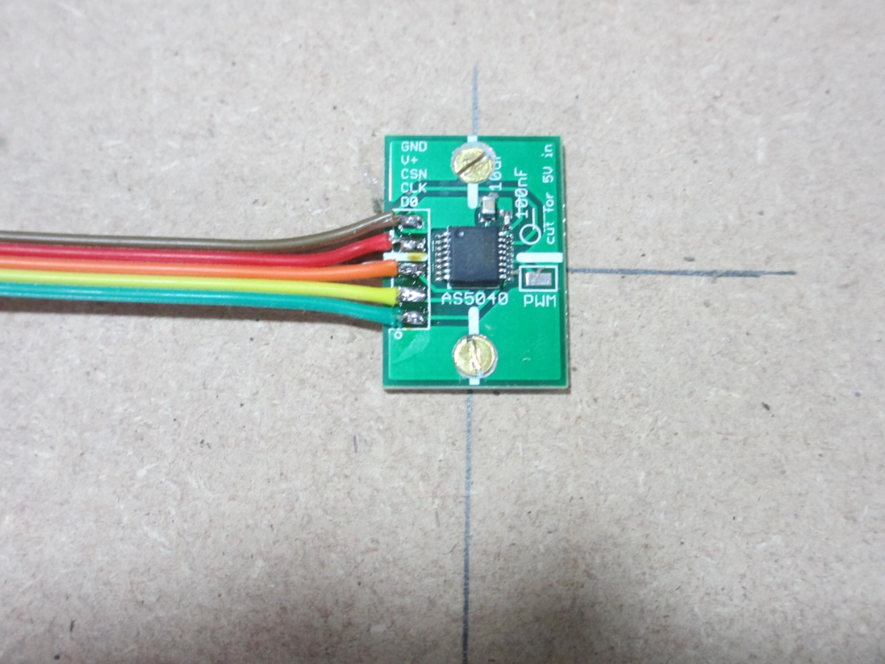

**Odometer Sensor Board Attachment to Chassis Side**

***Geek’s Box:*** *The Odometers consist of a* Magnetic Rotary Encoder AS5040 with Magnet BMN-35H (Diametrically magnetised). The odometers work by having a magnet on the drive shaft that rotates over the centre of an IC. The IC measures the angle of the magnet to a resolution of about 1/3 degree. *The circumference of the drive wheel varies gradually with tyre wear, but is approximately 470mm. The theoretical accuracy of distance measurement is therefore approximately 0.46mm. [pi*diameter/1024].*

*The lateral distance between the wheels (wheel track) is approximately 240mm. The theoretical accuracy of measurement of robot heading using the odometers is therefore approximately 0.11 degrees [arcsin(0.46/240)]*

*The individual odometer readings are sent to the R-Pi using a synchronous serial interface operating at about 50 K Baud. They are read simultaneously to prevent latency errors when travelling at speed. To avoid ambiguities between forward and backwards wheel movement it is important to read the odometers before either wheel has rotated more than half a revolution. Reading the odometers every 47 msec will accommodate speeds of up to 5 m per sec (11MPH) [(470/2)/0.047]*

***[Geek: One who engages in or discusses computer-related tasks with great attention to technical detail]***

1. Replace the two motors ensuring they are firmly attached to the bottom of the chassis.

**2.2 Main Battery and Power Supply Converter**

The Autonomous system uses more power than a standard Rampaging Chariot. We therefore strongly recommend that you replace the existing drill batteries with a 7Ah Sealed Lead Acid Battery as recommended for standard Chariots on our web site under the ‘Basic Enhancements’ category.

<http://www.rampagingchariots.org.uk/enhancements/basic.php>

The batteries and charger are:

|  |  |  |  |
| --- | --- | --- | --- |
| 6v SLA Batteries 7AH (Spade Terminals 4.75x0.8mm) | Rapid | 18-1705 | £8.66 |
| 12v SLA Battery 7AH (Spade Terminals 4.75x0.8mm) | Rapid | 18-1713 | £13.86 |
| 12v / 6v Automatic SLA Charger - Ansman | Rapid | 18-3959 | £15.74 |

* + 1. Design and make a battery tray or individual restraints, to anchor the battery pack to the base.

Velcro pads would also be OK provided you are not playing football.

* + 1. Either fit a 15 Amp spade fuse between the battery cells (supplied) or fit 15 Amp spade fuses to each Motor Drive Board supply.
    2. Fit the Blue Tri-Connector (supplied) to the battery negative terminal and connect the two motor Drive board black wires
    3. Extend the front and back motor drive board red wires with the short and long extension wires (supplied)

These extension wires will plug into the Motor Power ON/OFF switch on the new lid

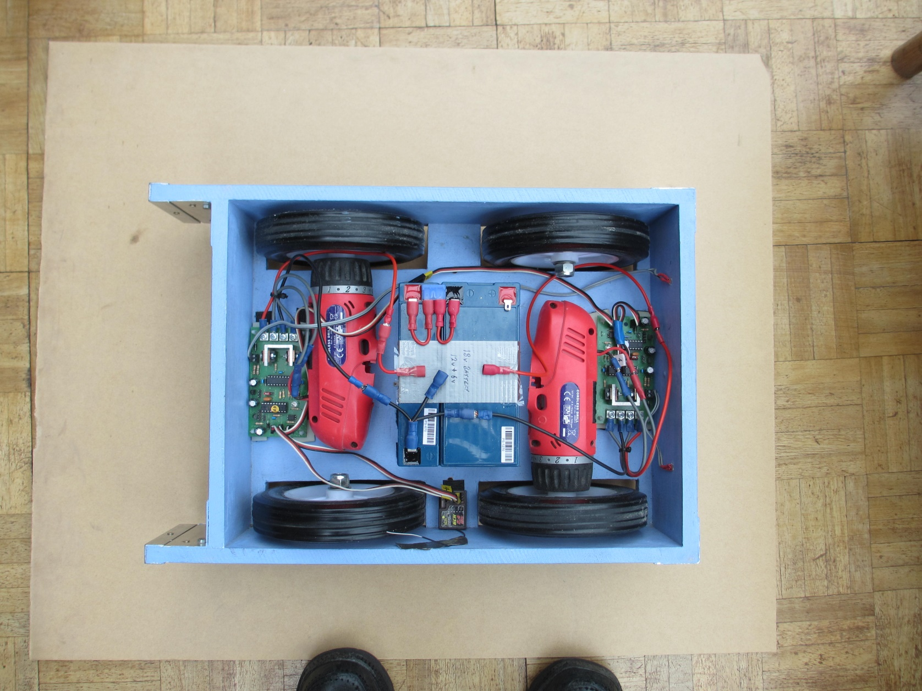

**Single Sealed Lead Acid Battery With Fuse and Connectors**

**2.3 Motor Drive Boards**

The Rampaging Chariot Master Motor Control Board controls one drive motor and outputs commands to the Slave Motor Control Board which drives the second motor.

**Motor Control**

**from Sensors Board**

Rx Tx Gnd

**Insulate this spare 5v pin**

**Manual/Auto Jumper**

Master/Slave Jumper

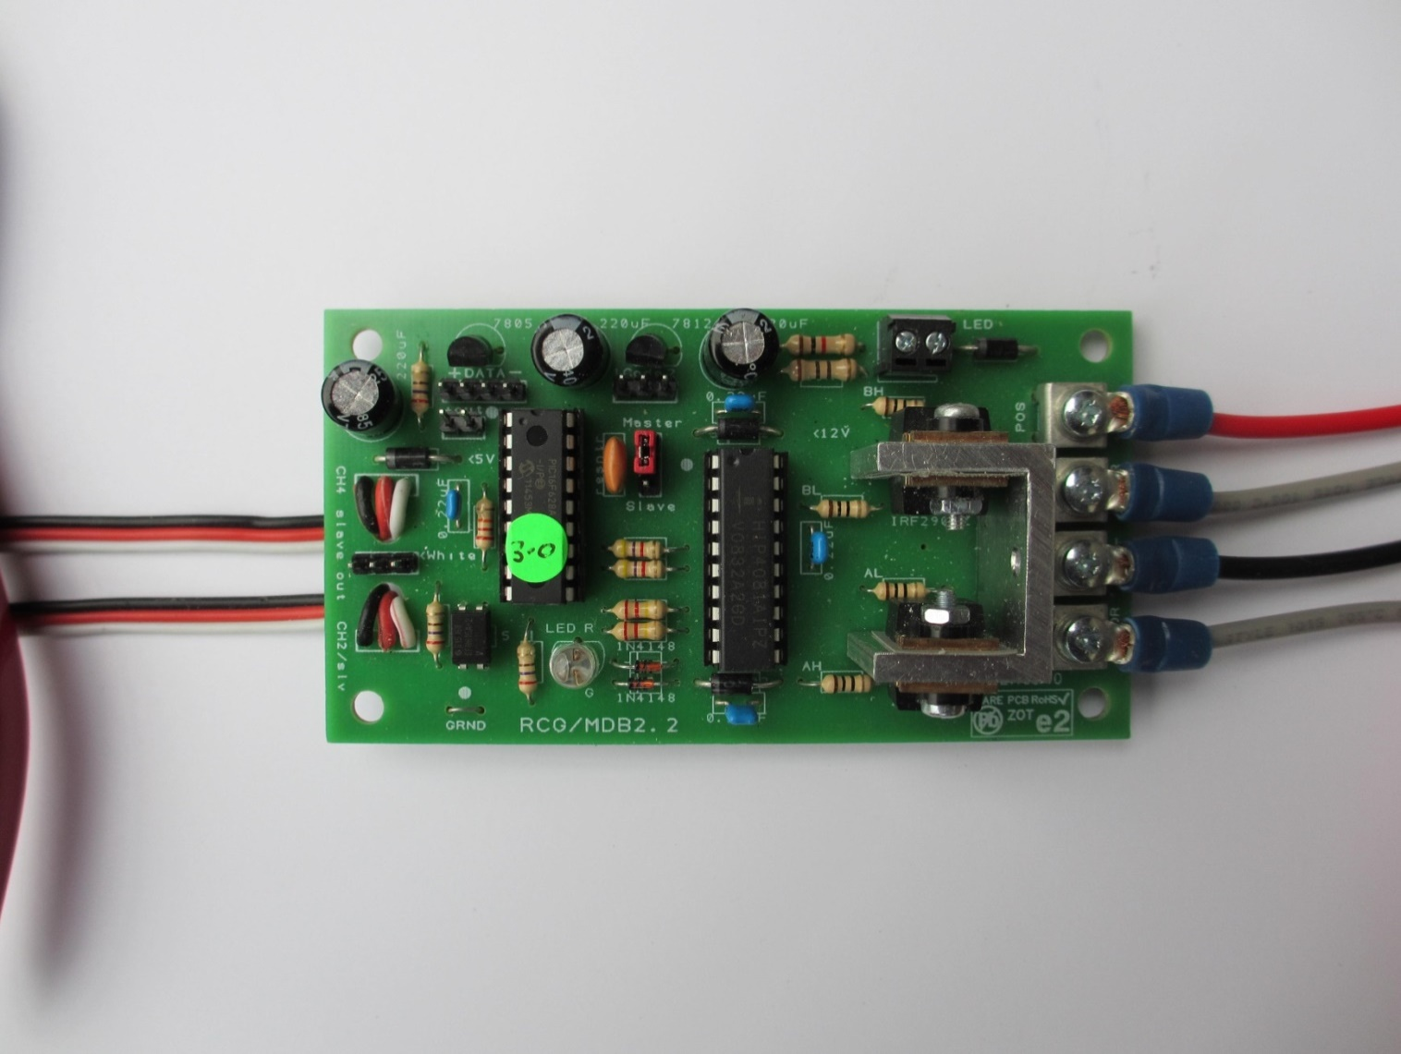

**Radio Receiver**

**Channel 4**

**Auto V1.0**

**Master Motor Drive Board**

**Radio Receiver**

**Channel 2**

**The Master Board PIC**

1. Replace the Master Board PIC with a PIC containing the new AUTO V1. software standard.

***Geek’s Box;*** *In the normal (Manual) Mode, Control commands of Longitudinal Speed and Lateral Turn Rate are provided by two Pulse Width Modulated (PWM) signals from the radio receiver.*

*In the new (Autonomous) Mode, the two commands are sent from the R-Pi using a Universal Asynchronous Receive/Transmit (UART) serial link.*

*The standard input logic for catching glitches, together with motor output limiting and a linear filter helps to prevent excessive stress on the motor gearboxes.*

**The Master Board Auto/Manual Mode Jumper**

1. Fit a jumper to the three pin header. For Autonomous Mode the centre pin is connected to the right pin of the three pin header. For Manual (radio control) Mode the centre pin is connected to the left pin of the three pin connector.

**The Master Board Autonomous Serial Input**

The four pin header on the Master Motor Control Board is used for the Autonomous Serial Input.

1. Connect the right three pins of this header to the Sensors Control Board as shown. It is important that the Black wire is on the correct pin.

***Geek’s Box:*** *The Autonomous serial input is a bi-directional Universal Asynchronous Receive/Transmit link (UART) operating at 38.4 K Baud using 8-N-1 protocol. The link transmits two 8-bit bytes containing numbers between 0 and 255. The first byte is the longitudinal (forward/back) speed demand and the second byte is the lateral (left/right turn rate) demand.*

*The zero datum is 127 decimal. 127+x demands forward speed and 127-x demands rearward speed.*

*The two bytes are sent from the R-Pi every 16 msec. If they are not received, or a value of zero is received, the system will shut down until a valid signal is again received.*

*The R-Pi operates on 3.3v and the Rampaging Chariot PIC operates on 5v. To prevent serious damage to the R-Pi, the autonomous serial link is routed through a Voltage Level Shifter mounted on the Sensor Interface Board.*

**The Slave Board PIC**

1. Replace the Slave Board PIC with a PIC containing the new AUTO V1. software standard.

This is to ensure that power outputs to both motors is the same.

The **Master/Slave Jumper** on both master and slave boards continues toselect whether that motor drive board is a Master or a Slave.

The **Green/Red LED** on both boardsilluminates Green to indicate the Pulse Width Modulated (PWM) output to the Motor Driver IC. The brightness is proportional to the motor speed demanded.

In Manual mode the **Red LED** indicates that an invalid input signal is being received from the radio receiver (or the master board)..

In Autonomous Mode the **Red LED** indicates the R-Pi is not providing a regular valid signal, or the Motor Drive Board is inhibited.

**2.4 Constructing The Robot Lid**

The Robot Lid is purely a platform to mount the Autonomous electronics, Sensors and Actuators. The following suggestion is one of the simplest designs which extends the height of the existing chassis frame:

1. For the front and back cut 2 pieces of 12mm thick MDF 286mm long and 30mm wide
2. For the sides cut two pieces of 12mm thick MDF 400mm long and 30mm wide.
3. Place the four lid pieces over the sides of the chassis, and mark the positions of the four screws that will hold the lid sides together. These are 6mm from each end of the long side pieces.

1. Drill and countersink 3mm dia holes for the screws and pilot drill (2.5mm) through these holes into the ends of the short sides to stop the ends of these sides splitting.
2. Glue and screw the four side pieces into a rectangle, using four M3 x 30mm wood screws.
3. Cut a top lid of 3mm or 4mm thick MDF (or Plexiglass, Perspex, Plywood) 400 x 310mm.
4. Drill ten 3mm holes round the lid 6mm from the edge where shown and countersink the lid so that the screw heads are flush with the top.

DO NOT fix the lid to the frame yet as it is easier to cut holes in the lid whilst it is flat.

**Fitting Components to the Lid**

1. Mark out the positions of the four switches, the stepper motor and the servo motor.
2. Cut out the rectangular holes for the four switches using a coping saw, or drill several holes with a 6mm drill starting in the corners and then file out the hole. Do not make the length of the holes too long or the clips holding the switches in will be very loose.
3. Drill a 9mm hole for the stepper motor shaft on the centre-line of the lid 35mm from the front edge.
4. Place the stepper motor upside down on the top with wires towards the centre of the lid and draw round the positions of the 4mm bolt holes. Drill these two holes and countersink the top of the lid.
5. Make a rectangular hole 23mm x 12mm for the servo motor with a coping saw, or drill several holes with a 6mm drill starting in the corners and then file out the hole. Do not make the hole too long or it will interfere with the servo mounting holes.

35

12

25

M2

20

9dia

M4

23

M3

21.5

12

15

31

13

20

70

70

70

70

6

20

13

30

100

**Hole Dimensions in mm**

**Sensors Interface Board**

**Raspberry Pi**

**Motors Power**

M2

**Stepper Motor**

**Micro Switch**

**Servo Motor**

**Sensors Power**

**R-Pi Power**

**Sensor Motors Power**

11

**8mm Cable Holes**

**In line with Pins**

**U-S 8mm Cable Hole**

**9mm**

35

**Sensors Power 8mm Cable Hole**

**R-Pi Power 8mm Cable Hole**

**Positions of the Autonomous Components on the Lid:**

**Mounting the Servo Motor**

1. Insert the servo motor from underneath with wires towards the centre of the lid and drill two 2mm bolt holes through the flanges into the lid.
2. Attach the Servo motor with two M2 x 10m C/S bolts and nuts.
3. The two sensor motors vibrate a lot so to avoid the nuts vibrating loose and dropping onto your main motor circuit boards and causing electrical shorts and smoke we recommend you put glue such as Prit Stick on the bolt threads before screwing on the nuts, to stop the nuts coming off

***Geek’s Box:*** *The Servo Motor contains a 5v motor, a reduction gearbox and a potentiometer. It receives a pulse wave modulated (PWM) signal from the PIC. Internal logic causes the motor to turn until the potentiometer feeds back a voltage proportional to the angle of rotation demanded.*

*The shaft is free to turn through 180 degrees corresponding to a PWM width of between about 1ms and 2 ms. The zero datum is 1.5ms.*

**Mounting the Stepper Motor**

1. Insert the stepper motor from underneath and fix into position with two M4 x 6mm countersink bolts and nuts.

***Geek’s Box: The*** Stepper Motor 28BYJ-48  is a motor controlled by a series of electromagnetic coils. The centre shaft has a series of 8 magnets mounted on it. Surrounding the shaft are 4 coils which are alternately given current or not, creating magnetic fields which repulse or attract the magnets on the shaft, causing the motor to rotate. This design allows for very precious control of the motor.

This motor is called a unipolar stepper because current always flows in the same direction through each coil. The 4 coils are energised in a specific sequence of 8 codes that are generated by the PIC:

The switching sequence is 1000, 1100, 0100, 0110, 0010, 0011, 0001, 1001

Each new code rotates the motor by one half step.

The Stepper Motor is constructed with 64 discrete half steps per 360 degrees giving a resolution of 5.625 degrees. This is very poor resolution so the motor has a mechanical gearbox with a reduction ratio of 1:64 which provides a resolution of 0.088 degrees. (4096 steps per 360 degrees)  
The specified motor Torque (twisting force) is 34.3mN.m

**Fixing the Lid to the Chassis**

1. Screw the lid to its frame using ten M3 x 12mm wood screws
2. Attach the frame to the front chassis with the two hinges supplied using M3.5 x 12mm wood screws.

**2.5 Connecting the Power Supply Cables**

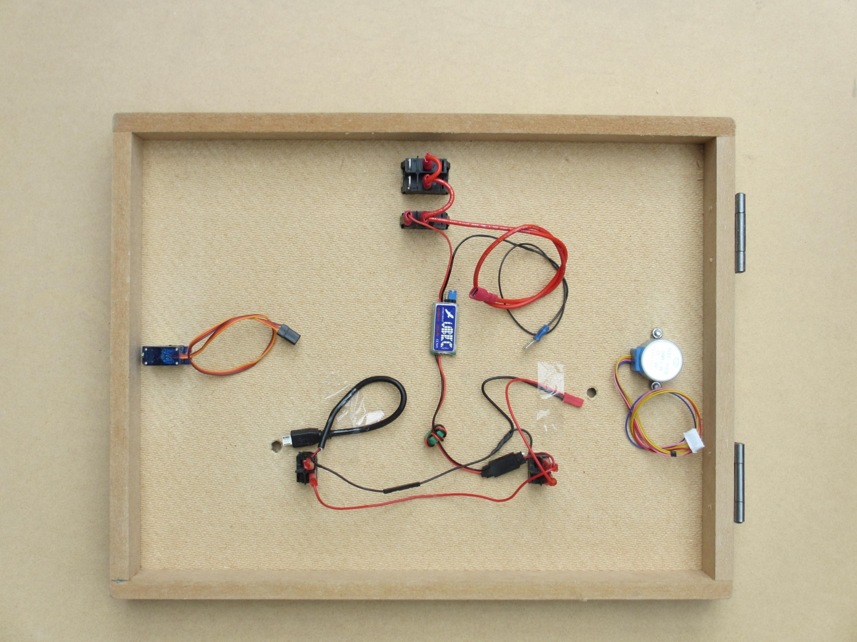

**Front**

**Bottom of Lid Showing Power Supply Cables and UBEC**

Whilst connecting the power switches **DO NOT** connect the battery power. We recommend you also remove the Battery fuse.

1. Push the four switches through the top of the lid until they click into place. The ON selection should be towards the front of the chassis or towards the autonomous boards they power. The green switch is for the sensor motors and the red switch is for the R-Pi.
2. Fit the **Main Battery Cable**. Push the red spade connectors onto the switch terminals as shown in the picture whilst supporting the top of the switch to prevent them being pushed out of their holes.
3. Fix the **UBEC** to the underside of the lid with the Velcro pads. Connect the red spade to its power switch.

***Geek’s Box:*** *The new Power Supply Converter is a switched mode PSU capable of providing 5v at 3 Amps continuously from the 18v robot battery. It supplies the Autonomous system including the Raspberry Pi, the Sensors Control Board and the Scanning Actuators. It is called a UBEC (Universal Battery Eliminator Circuit) and is designed for drones.*

1. Push the **R-Pi Power Cable** through its hole and connect the Red spade connector to the switch.
2. Attach the **Sensors Board Cable** to the UBEC output socket. Push the red spades onto the switches. Connect the single wire to the R-Pi cable. Finally push the sensors plug up through the hole in the lid.

**Motor Power Sw Switch**

**50 Extension**

**320 Extension**

**50**

**60**

**Auto Power Sw Switch**

**Power Cable**

**380**

**Odometer**

**Wheel**

**Wheel**

**15A**

**Fuse**

**50mm Fuse Connectors**

**Auto PIC**

**Motor**

**Master**

**Motor**

**Control**

**Board**

**Slave**

**Motor**

**Control**

**Board**

**18v Battery**

**12v**

**Auto//Manual Jumper**

**Motor**

**6v**

**Auto PIC**

**Tri-Connector**

**Rx**

**Wheel**

**Wheel**

**260 Extension**

**Odometer**

**Power Supply Converter (UBEC)**

**18v to 5v 3A**

**Right Odometer**

**To Sensors Board**

**Motor Control UART**

**From Sensors Board**

**Left Odometer**

**To Sensors Board**

**Sensors Switch**

**R-Pi**

**Switch**

**220**

**50**

**220**

**50**

**R-Pi Power Cable**

**Sensors Power Cable**

**Socket & Pin**

**220**

**70**

**80**

**80**

**2.6 Fitting the Sensors**

**Mounting the Infra-Red Range Sensor**

1. Mount the Infra-Red Sensor on the 3D printed bracket and fix this bracket to the Stepper Motor shaft using the M2.5 x 6mm fixing screw supplied. Do not over tighten

**Geek’s Box:**The Infra-Red Range Sensor is a Sharp 2Y0A02 YK. This has a range of 200mm to 1500mm. with an effective beam angle of <15deg. The specified resolution is 3mm.

The transmitter is an IRED (infra-red emitting diode) operating at λ = 850nm

The receiver is a PSD (position sensitive detector) and the device contains a signal processing unit.

Operating voltage is 5v with a current of 33mA.

The output is an analogue voltage varying non linearly between 0.4v at 1500mm and 2.75v at 150mm

**Mounting the Stepper Motor Datum Micro Switch**

1. Position the Datum Micro Switch on the top surface such that it operates when the Infra-Red sensor rotates approximately 110 degrees in an anti-clockwise direction from dead ahead.
2. Drill two 2mm holes and fix the switch in position using two M2 x 12mm round head bolts.

***Geek’s Box:*** *When datuming, the stepper motor and sensor will rotate anti-clockwise until it reaches the datum switch and then rotate back clockwise by approximately 110 degrees to the straight ahead position. The exact angle can be adjusted in software during the sensor calibration process in Part 3*

**Mounting the Ultra-Sonic Range Sensor**

1. Push the 3D printed bracket onto the Servo Motor shaft and fit the central retaining screw supplied. If the bracket is loose use some glue, but be careful not to get any glue into the servo motor
2. Mount the Ultra-Sonic Sensor onto the 3D printed bracket using two M2 x 10mm screws and nuts.

**Geek’s Box:** The Ultra-Sonic Range sensor is an HC-SR04 with a range of 20mm to 4000mm

like a car reversing sensor it transmits a 10us pulse of high frequency sound at 40KHz which is above the human range. It then times the interval between transmission and receiving the echo from an object in the field of view

power supply :5V DC

quiescent current : <2mA

effectual angle: <15°

ranging distance : 20mm – 5000mm

resolution : 3 mm

The range in mm is the pulse width in us/5.88 (Speed of sound = 340 m/s at Sea Level (760mph))

**2.7 Constructing The Sensors Interface Board**

**The Sensors Interface Board** is provided to handle time critical tasks that could monopolise the computing resources of the Raspberry–Pi and delay the execution of the main navigation & control programme.

***Geek’s Box:*** *The Sensors Interface Board receives sensor commands from the Raspberry Pi, sent via an**I²C (Inter-Integrated Circuit) bi-directional serial link. In our application the link is configured to have one controlling Master (The R-Pi) and multiple Slaves that can be individually addressed. In I²C WRITE mode the R-Pi addresses the Sensors Interface Board and tells it which sensor or actuator it wants to do a particular action. In I²C READ mode the R-Pi addresses the Sensors Interface Board and requests the Current Reading and Status of a particular sensor or actuator.*

*The Sensor Interface Board contains a two-way voltage level shifter (between 3.3v and 5v), a stepper motor driver IC and a PIC (Programmable Interface Controller).*

*If required, the Raspberry Pi can control several Sensor Interface boards or other commercial sensors via the I2C interface. (I2C bus extension pins are provided on the sensors board for a 5v and 3.3v bus.)*

The Sensors Board is made in the same way as the standard kit Motor Control Boards.

**The components are inserted into the board and soldered in sequence with the lowest height components first.**

**The Sockets and Header Pins**

1. Insert the black right angle header pins into the board and solder into place.
2. Insert the white right angle header pin socket into the board and solder into place
3. Insert the two 14 pin and 16 pin IC sockets on the PCB and solder the pins under the board.
4. Insert the 20 pin box header on the board and solder the pins under the board. The gap in the side of the header goes towards the edge of the board

***Geek’s Box:*** *Make sure the sockets are positioned the correct way round as indicated by the small indent in the end of the socket.*

*Solder two opposite diagonal pins first, check that the socket is flat on the top surface of the board and, if necessary, re-solder the two diagonal pins before finally soldering all the other pins.*

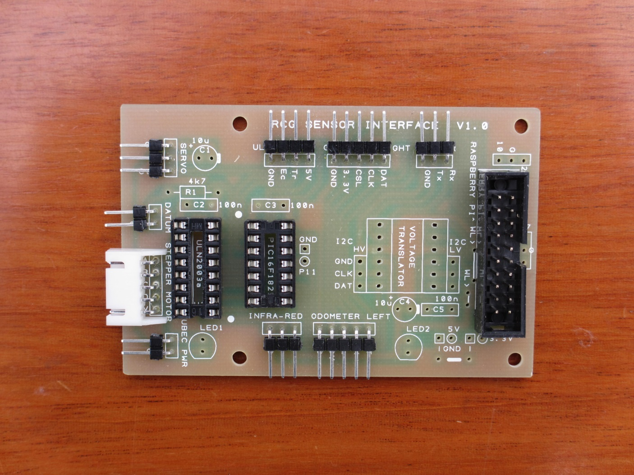

**Sockets and Header Pins**

**The Voltage Level Shifter**

The Voltage Level Shifter is a four channel bi-directional device that changes the voltage between the 3.3v used by the Raspberry Pi and the 5v used by the sensors, actuators and PICs.

1. Insert the Voltage Level Shifter into the PCB **the correct way round** (Low voltage side, marked LV, towards the 20 pin box header- see picture on next page) and solder the pins under the board.

**The Capacitors, Resistors, LEDs and Straight Header Pins**

1. Insert the 4K7 resistor and solder into place
2. Insert the two 5v Red LEDs with their short lead towards the edge of the board (and the flat indication on the printed symbol on the board).
3. Insert the 0.1uF (marked 104) capacitor on the board and solder into place
4. The 10uF electrolytic capacitors C1 and C4 are not required

***Geek’s Box:*** *The Red LED nearest the R-Pi indicates when 5v power from the R-Pi is present on the Sensors Interface Board. The Red LED nearest the Stepper motor socket indicates when 5v power from the robot battery is present to power the stepper motor and servo motor The power required for these two motors exceeds the power supply capability of the R-Pi.*

*A few components are not fitted. The 10uF capacitors are not required and the extra header pins positions are available for future expansion. The vertical 3 pin headers either side of the voltage translator are available to allow the I2C data bus to be extended to additional sensors. Both 5v and 3.3v I2C buses are available.*

**The Stepper Motor Driver IC**

The Stepper Motor takes more power than can be provided by the PIC microprocessor. We therefore use a Motor Driver IC to increase the power supplied to the Motor Coils.

**Geek’s Box:** Each coil of the 28-BYJ48 Stepper Motor consumes 100ma at 5v which exceeds the supply capability of the PIC. We therefore use a ULN2003 Motor driver chip which contains 7 pairs of high-voltage, high-current NPN Darlington transistor arrays, each capable of handling 500ma current.  We use 4 of its seven channels for our stepper motor coils.

1. Insert the Stepper Driver IC ULN 2003 into its black socket the correct way round.

***Geek’s Box:*** *This IC has a small indentation in one end to indicate the orientation.*

*This indent should line up with the indent in the end of the socket.*

**The PIC (Programmable Interface Controller)**

***Geek’s Box:*** *The PIC is a MICROCHIP PIC16F1823-E/P DIP-14. It operates at 32MHZ,*

*It handles the pulse sequences required to drive the stepper motor and a servo. It also converts analogue I-R range into a digital format and converts pulse width signals from the ultra-sonic range sensor into a digital format. It is powered from the Robot battery via the R-Pi.*

*The PIC is extremely versatile and is suited to providing interface tasks that are time critical such as pulse generation and pulse width timing measurement. It undertakes:*

*The Slave I2C serial interface Sensors sampling*

*Analogue to Digital conversion (A2D) Stepper Motor 4 Phase coil logic outputs*

*PWM (Pulse Wave Modulation) generation PWM to Digital conversion*

*The PIC has the ability to store certain interface parameters and allows these to be modified as required to accommodate new or different sensors*

1. Insert the PIC IC 16F1823 into its black socket the correct way round.

Note the two ICs are fitted in opposite directions.

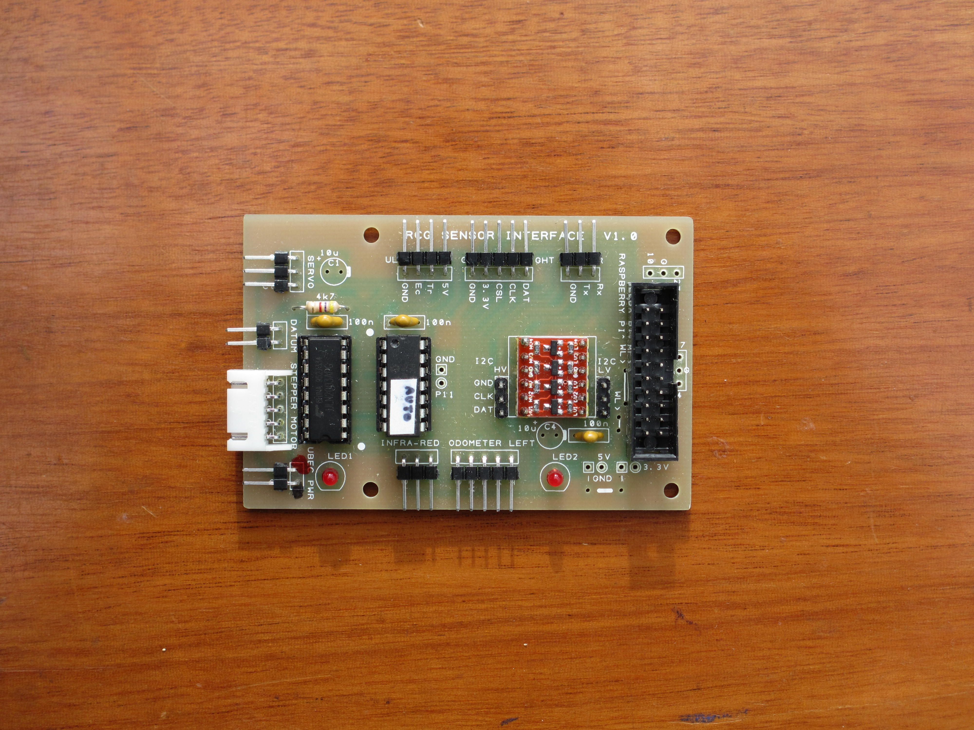

**Completed Sensors Board**

**Mounting the Sensors Interface Board**

1. Position and Glue the Sensors Interface Board tray on the top surface using four sticky Velcro pads.
2. Insert the Sensors Interface Board into the tray.
3. Drill 8 mm diameter holes in the lid about 25mm from edge of the board, to accept the connection plugs. The hole for the stepper motor plug will need to be 9mm diameter. See picture of lid on next page.

**Mounting the Raspberry Pi Microprocessor**

1. Position and Glue the Raspberry Pi tray on the top surface using four sticky Velcro pads.
2. Insert the Chariot Raspberry Pi into its tray. This is the Raspberry Pi with the central two GPIO pins bent over to enable you to insert the 20 pin plug and connecting ribbon cable.

***Geek’s Box:*** *The Raspberry Pi 3 Model B* is the third generation Raspberry Pi computer. It replaced the Raspberry Pi 2 Model B in February 2016. Compared to the Raspberry Pi 2 it has a faster (1.2 GHz 64 bit quad core) processor and incorporates both Wi-Fi and Bluetooth communication. It is described in Appendix ?.

**2.8. Fitting the Interconnecting Cables**

The interconnecting cables have different lengths and number of sockets. Identify the correct cables and make sure they are connected the correct way round.

1. **Master Motor Drive Board**. Feed the 500mm long three wire cable with female servo plugs at each end through the hole in the lid and plug into the Sensors Interface Board as shown below and into the Master Motor Drive Board as shown in Paragraph 2.2.
2. **Odometers**. Feed the left and right five wire odometer cables up through the holes in the lid and plug into the appropriate side of the Sensors Interface Board as shown.
3. **Stepper Motor**. Feed the five wire stepper motor cable and white plug up through the hole in the lid and insert it into the white plug housing (keyed) on the Sensors Interface Board
4. **Datum Micro Switch**. Plug the two wire cable into the Sensors Interface Board as shown.
5. **Infra-Red Sensor**. Plug the three wire cable into the Sensors Interface Board with the Black wire on the left ground pin as shown.
6. **Servo Motor**. Feed the three wire servo motor cable up through the hole in the lid and insert it into the Sensors Interface Board with the black wire on the ground pin as shown.
7. **Ultra-Sonic Sensor**. Attach the four wire cable to the Ultra-Sonic Sensor with the black wire on the ground pin. Feed the cable down through a hole in the top, under the lid and up through the appropriate hole. Plug the wires into the Sensors Interface Board with the black wire on the ground pin. Leave enough wire on top of lid to let sensor rotate.
8. **Sensors Board Motors Power Cable**. Plug this two wire cable into the Sensors Interface Board with the black wire on the ground pin.
9. Connect the **Interface Cable** between the Raspberry Pi GPIO Header and the Sensors Interface Board Header. (This cable will fit neatly between the two boards if it is bent as shown)

Then **UNPLUG** **this cable and the R-Pi power cable** until you are ready to test the R-Pi.

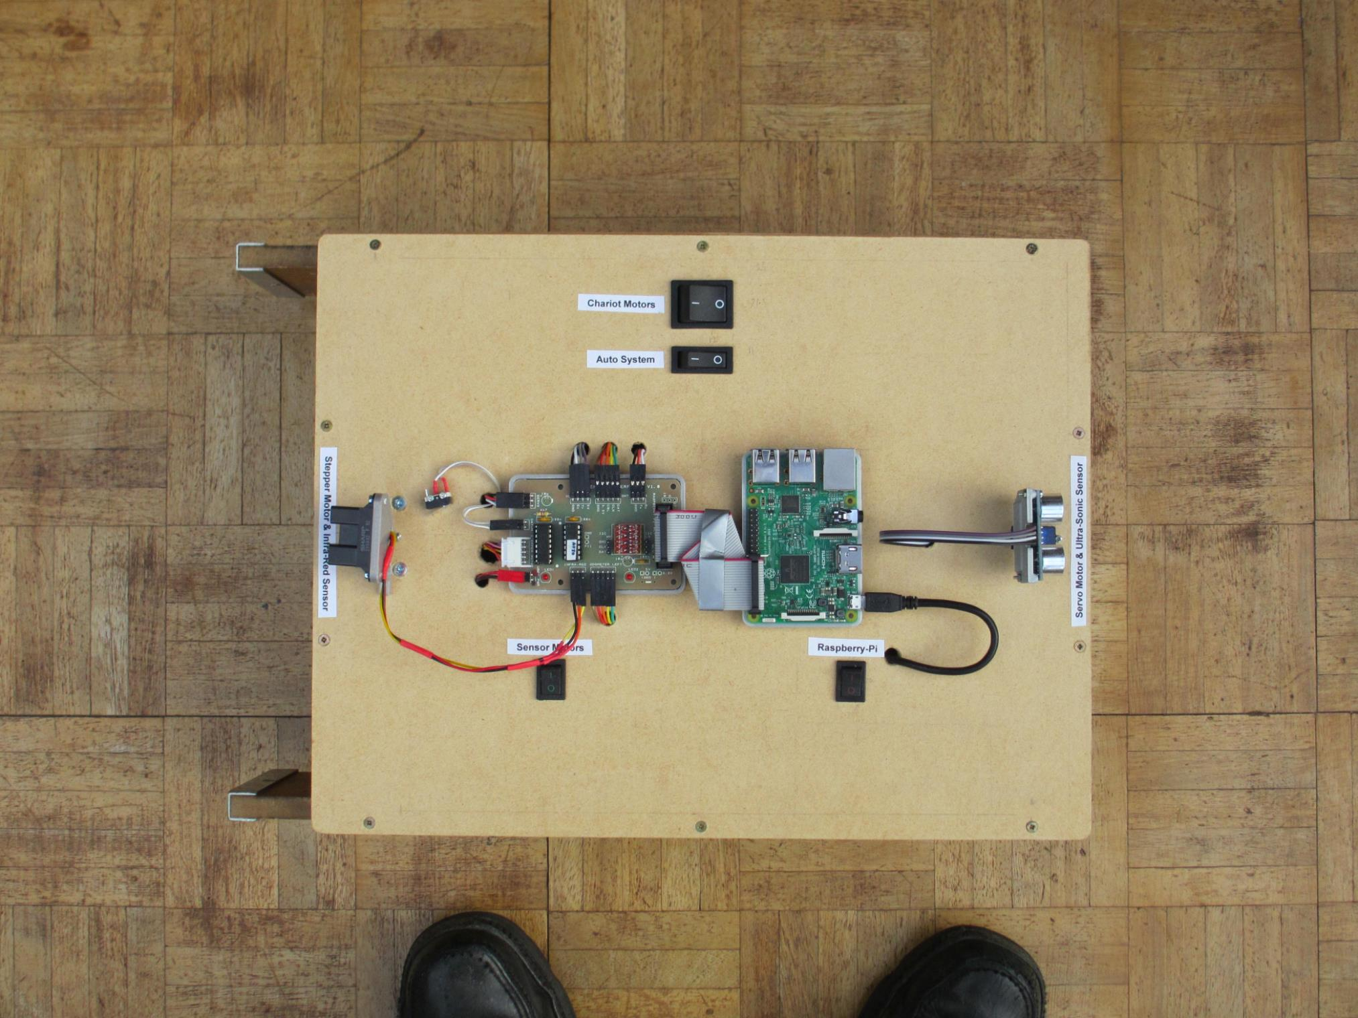

**The Completed Lid - What about some paint?**

(Note: The labels to identify switches and sensors are peeled off the plastic bags)

**Testing the Power to the Sensors Board**

When the switches, cables and sensors have all been connected ask your teacher to check that you have plugged all the cables into the correct pins on the Sensors Interface Board, the master Motor Drive Board, the Sensors and the Scanning Motors (called Actuators). In particular check that all the Ground wires are connected to the Gnd pins and the other coloured wires are connected in the sequence of the ribbon cable. (See ‘The Completed Lid’ photo on previous page)

1. Connect the Battery and fit the battery fuse.
2. Switch on the Auto System switch and check the red LED on the UBEC Power converter is illuminated.
3. Switch on the Sensors Power Switch and check the red LED 1 on the sensors board is illuminated.

The red LED 2 on the Sensors Board nearest the R-Pi

**2.9 Testing the Manual Mode**

Check that your modified Rampaging Chariot still operates like a normal Radio Controlled Robot.

1. Check the robot is supported on a wooden block with wheels free to rotate.
2. Fit the Auto/Manual jumper is in the **Manual** position on the Master Motor Drive Board



Jumper in Manual Position

1. Switch on the ‘Motor Power’ Switch on the lid. The red LEDs on the two Motor Drive Boards should flash 5 times and then go steady Red. The two Red LED lights at the back of the Chariot should also illuminate. If the LEDs described do not illuminate, check the circuit from battery to LEDs with a voltmeter and remember LEDs need to be connected the right way round.
2. Turn on the Transmitter. The two LEDs on the Motor Drive Boards should go out to indicate that the robot is receiving a valid radio signal.
3. Operate the Forward/Back control stick and check the wheels turn in the required direction. If either wheel turns the wrong way, reverse its motor electrical connections by swapping the crimp connectors.
4. Operate the Left/Right control stick and check the wheels turn in opposite directions and the correct way. If the directions are wrong operate the channel 4 reverse switch on the transmitter (The channel reverse switches are at the bottom of the transmitter front face).
5. Check that the Green LEDs on both Motor Drive Boards illuminate in proportion to stick deflection. Move the two trim sliders on the transmitter to trim out any residual movement when the two sticks are central.